| **S.NO.** | **TITLE** | **PAGE NO.** |
| --- | --- | --- |
| 1. | Write a program (using fork() and/or exec() commands) where parent and child execute:  a) same program, same code.  b) same program, different code.  c) before terminating, the parent waits for the child to finish its task, both for above mentioned cases a) and b). |  |
| 2. | Write a program to show how multiple fork() system calls work. |  |
| 3. | Write a program to report behaviour of Linux kernel including kernel version, CPU typeand model. (CPU information). |  |
| 4. | Write a program to report behaviour of Linux kernel including information onconfigured memory, amount of free and used memory. (Memory information). |  |
| 5. | Write a program to print file details including owner access permissions, file accesstime, where file name is given as command line argument. |  |
| 6. | Write a program to copy files using system calls. |  |
| 7. | Write a program to implement FCFS scheduling algorithm. |  |
| 8. | Write a program to implement Round Robin scheduling algorithm. |  |
| 9. | Write a program to implement SJF scheduling algorithm. |  |
| 10. | Write a program to implement non-preemptive priority based scheduling algorithm. |  |
| 11. | Write a program to implement preemptive priority based scheduling algorithm. |  |
| 12. | Write a program to implement SRTF scheduling algorithm. |  |
| 13. | Write a program to calculate sum of n numbers using thread library. |  |
| 14. | Write a program to implement first-fit, best-fit and worst-fit allocation strategies. |  |

1- (a) #include<iostream>

#include<unistd.h>

#include<sys/types.h>

#include<sys/wait.h>

using namespace std;

int main()

{

int code=fork();

int status;

if(code<0)

{

cout<<"UNSUCCESSFUL"<<endl;

}

else

{

cout<<"ProcessID = "<< getpid() << endl;

cout<<"return code : " << code << endl;

}

return 0;

}

OUTPUT:

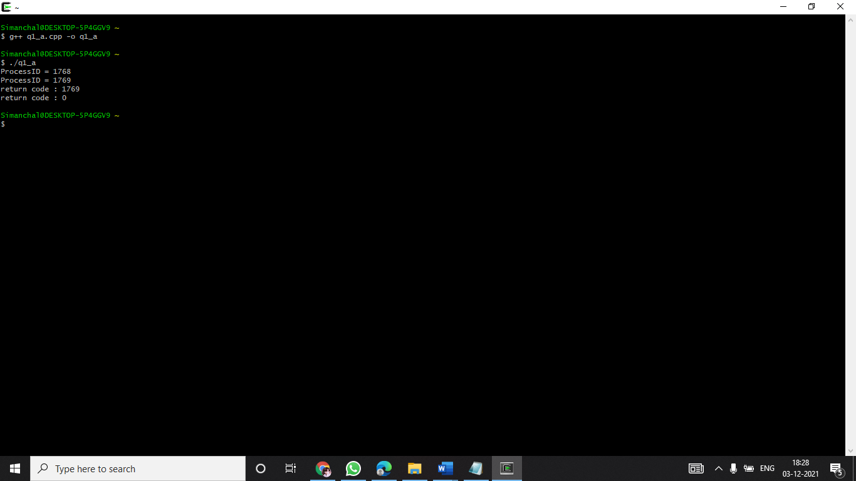

(b)

#include<iostream>

#include<unistd.h>

using namespace std;

int main()

{

int pid = fork();

if (pid<0)

{

cout<<"UNSUCCESSFUL"<<endl;

return -1;

}

else if(pid==0)

{

cout<<"I am a child process" <<" "<< pid <<" " <<getpid()<<endl;

}

else

{

sleep(-5);

cout<<"I am parent process " <<" " << pid <<" " << getpid() <<endl;

}

return 0;

}

OUTPUT:

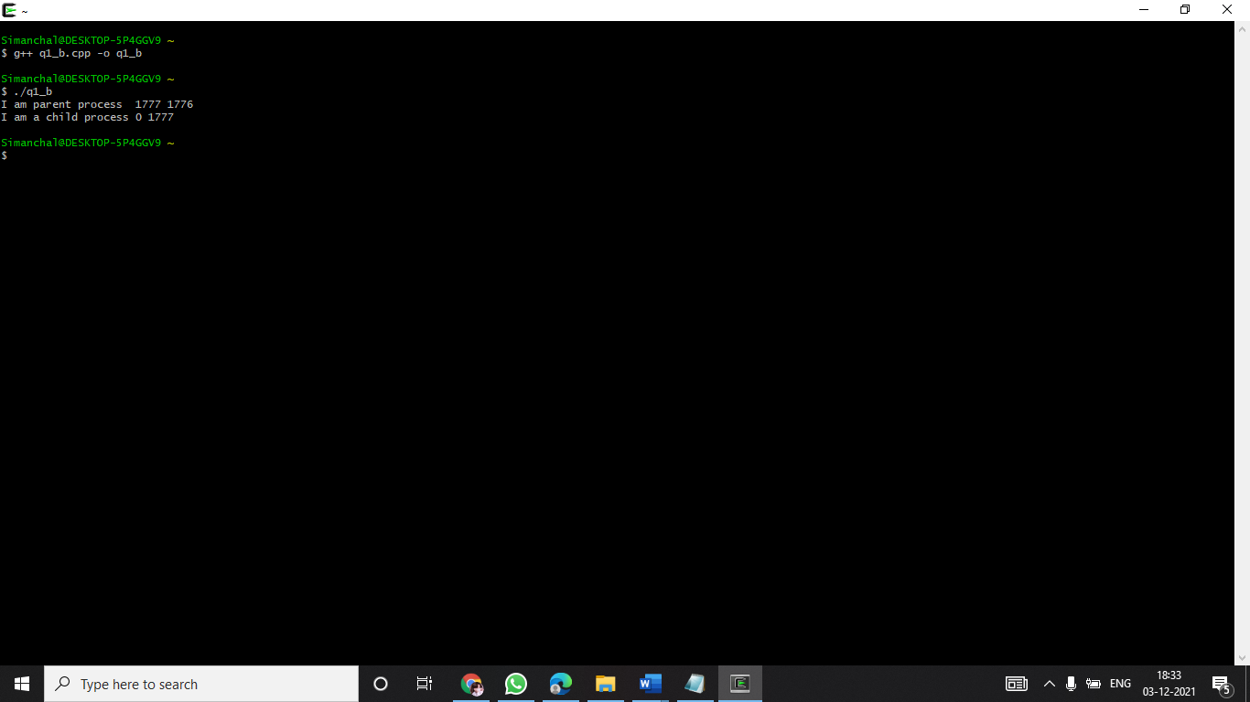

(a)-(c)

#include<iostream>

#include<unistd.h>

#include<sys/types.h>

#include<sys/wait.h>

using namespace std;

int main()

{

int code = fork();

int status,x;

if(code<0)

{

cout<<"UNSUCCESSFUL"<<endl;

}

else //Run same code for child and parent process

{

x = wait(&status);

cout<<"pid= " <<" "<< getpid() <<" "<< "return code = " << code<<" "<<"x="<<" " << x <<endl;

}

return 0;

}

OUTPUT:

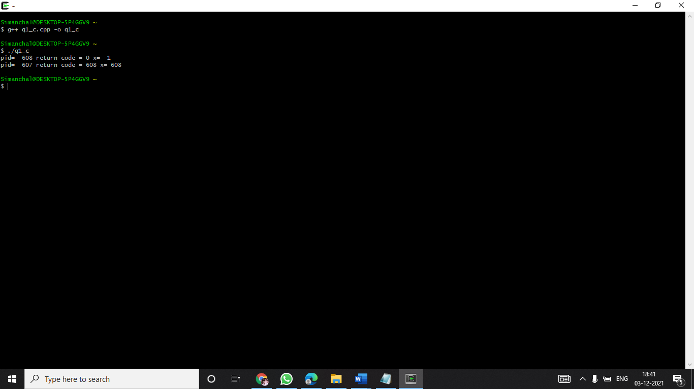

(b)-(c)

#include<iostream>

#include<sys/types.h>

#include<sys/wait.h>

#include<unistd.h>

#include<stdio.h>

using namespace std;

int main()

{

int status;

int pid=fork();

int x;

if(pid<0)

{

cout<<"Child process cannot be created\n";

return -1;

}

else if(pid==0)

{

cout<<"Child Executing : "<<pid<<"\n";

cout<<"\nI am Child. Child process id: "<<getpid()<<"\n";

execlp("/bin/ls", "ls", NULL);

}

else

{

x=wait(&status);

cout<<"\nChild complete \n";

cout<<"\nI am Parent. Parent process id: "<<getpid()<<"\n";

cout<<"\nInfo returned by wait(&status): "<<x<<" which is = child process

id\n";

}

return 0;

}

OUTPUT:

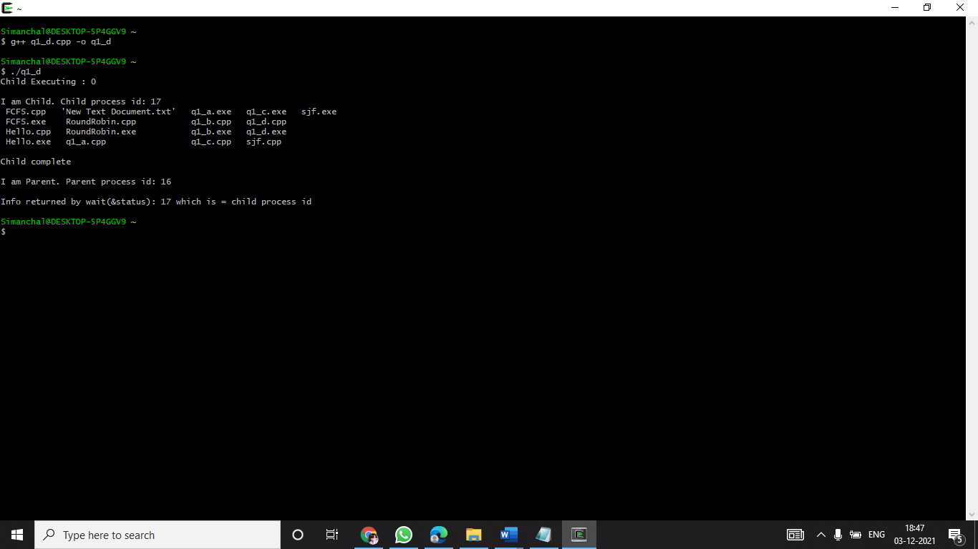

2-code:

OUTPUT:

3- Write a program to report behaviour of Linux kernel including kernel version, CPU typeand model. (CPU information).

-code:

#include<iostream>

using namespace std;

int main()

{

cout<<"\n Kernel version:\n";

system("uname -s");

cout<<"\nCPU space: \n";

system("cat /proc/cpuinfo |awk 'NR==3,NR==4{print}' \n");

return 0;

}

OUTPUT:

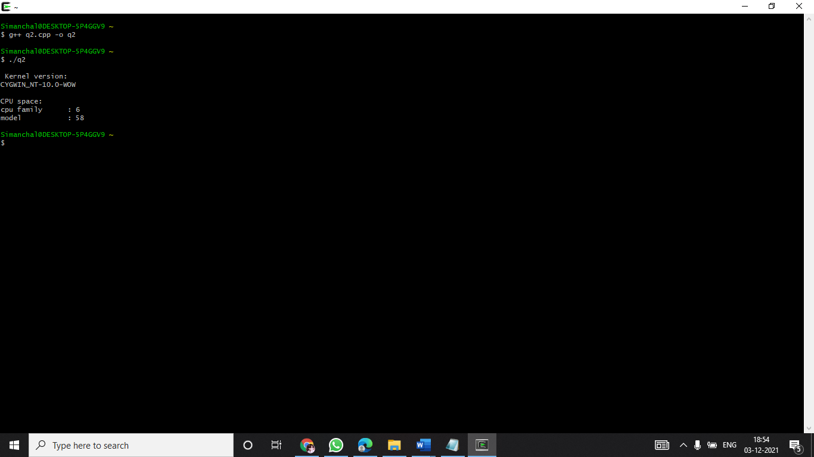

QUESTION 4:

Write a program to report behaviour of Linux kernel including information onconfigured memory, amount of free and used memory. (Memory information).

code:

#include<iostream>

using namespace std;

int main()

{

cout<<"\nConfigured memory is :\n";

system("cat /proc/meminfo |awk 'NR==1{print $2}'\n");

cout<<"\nAmount of free memory is :\n";

system("cat /proc/meminfo |awk 'NR==2{print $2}'\n");

cout<<"\nAmount of used memory is :\n";

system("cat /proc/meminfo |awk '{if (NR==1) a=$2; if (NR==2) b=$2 } END {print a-b}'\n");

return 0;

}

OUTPUT:

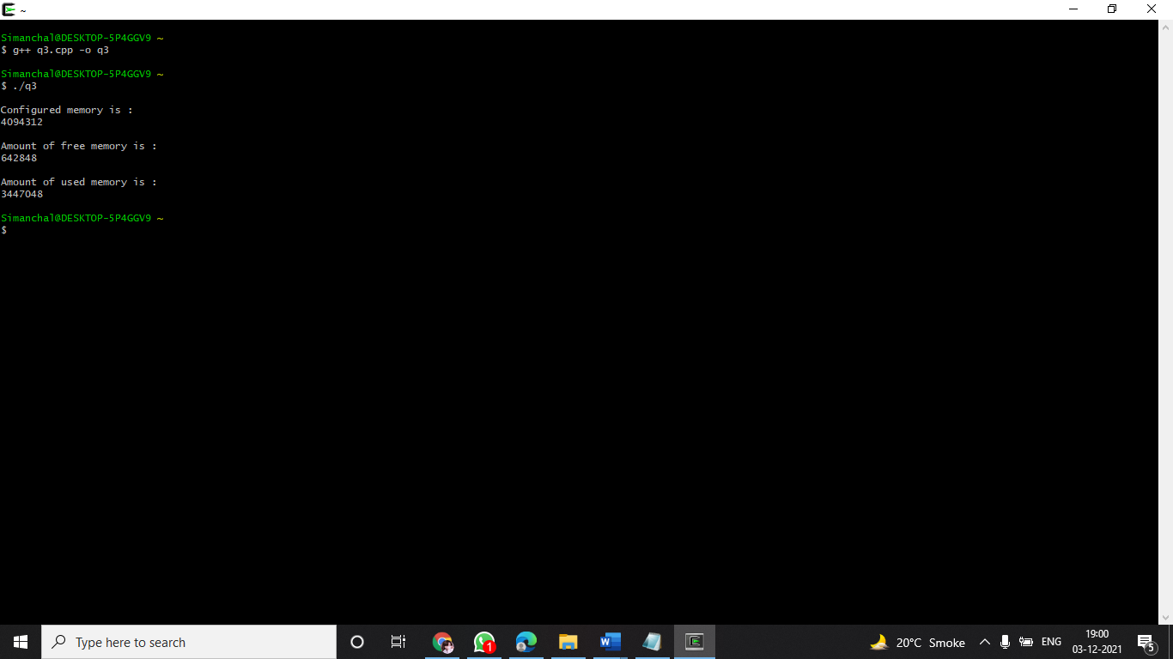

QUESTION 5:-

Write a program to print file details including owner access permissions, file accesstime, where file name is given as command line argument.

code:

#include<iostream>

#include<stdlib.h>

#include<stdio.h>

#include<unistd.h>

#include <sys/stat.h>

#include <sys/types.h>

using namespace std;

int main(int argc, char** argv)

{

if(argc !=2)

{

cout<<"\nEnter file name!\n";

return 1;

}

struct stat fileStat;

if(stat(argv[1],&fileStat)<0)

return 1;

cout<<"\nFile details for "<< argv[1]<<" are :\n";

cout<<"File Size: "<<fileStat.st_size<<" bytes\n";

cout<<" time of last access is : "<<ctime(&fileStat.st_atime);

cout<<" time of last modification is : " << ctime(&fileStat.st_mtime);

cout<<" time of last change is : "<< ctime(&fileStat.st_ctime);

cout<<"File Permissions: \t";

cout<<( (S_ISDIR(fileStat.st_mode)) ? "d" : "-");

cout<<( (fileStat.st_mode & S_IRUSR) ? "r" : "-");

cout<<( (fileStat.st_mode & S_IWUSR) ? "w" : "-");

cout<<( (fileStat.st_mode & S_IXUSR) ? "x" : "-");

cout<<( (fileStat.st_mode & S_IRGRP) ? "r" : "-");

cout<<( (fileStat.st_mode & S_IWGRP) ? "w" : "-");

cout<<( (fileStat.st_mode & S_IXGRP) ? "x" : "-");

cout<<( (fileStat.st_mode & S_IROTH) ? "r" : "-");

cout<<( (fileStat.st_mode & S_IWOTH) ? "w" : "-");

cout<<( (fileStat.st_mode & S_IXOTH) ? "x" : "-");

cout<<endl;

return 0;

}

OUTPUT:

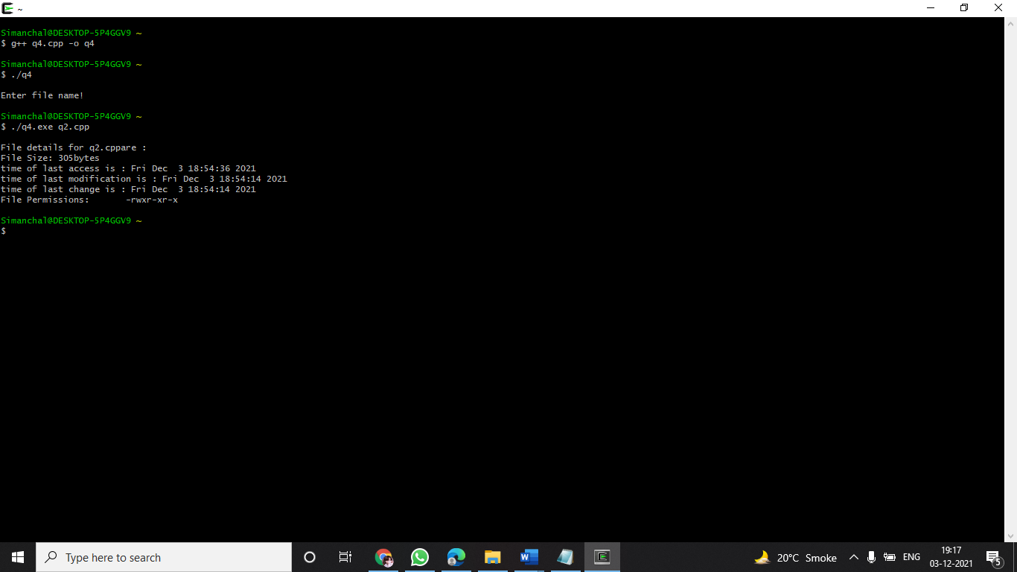

QUESTION 6:-

Write a program to copy files using system calls.

code:

#include <iostream>

#include <stdlib.h>

#include <fcntl.h>

#include <errno.h>

#include<unistd.h>

#include<sys/types.h>

#define BUFF_SIZE 1024

using namespace std;

int main(int argc, char* argv[])

{

int srcFD, destFD, nbread, nbwrite ;

char *buff[BUFF_SIZE];

if(argc != 3 || argv[1] == "--help")

{

cout<<"\nUsage: cpcmd source_file destination_file\n";

exit(EXIT_FAILURE);

}

srcFD = open(argv[1],O_RDONLY);

if(srcFD == -1)

{

cout<<"\nError opening file "<<argv[1]<<" errno = \n"<<errno;

exit(EXIT_FAILURE);

}

destFD = open(argv[2],O_WRONLY | O_CREAT | O_TRUNC, S_IRUSR |

S_IWUSR |S_IRGRP | S_IWGRP | S_IROTH | S_IWOTH);

if(destFD == -1)

{

cout<<"\nError opening file "<<argv[2]<<" errno = \n"<<errno;

exit(EXIT_FAILURE);

}

while((nbread = read(srcFD,buff,BUFF_SIZE)) > 0)

{

if(write(destFD,buff,nbread) != nbread)

cout<<"\nError in writing data to \n"<<argv[2];

}

if(nbread == -1)

cout<<"\nError in reading data from \n"<<argv[1];

if(close(srcFD) == -1)

cout<<"\nError in closing file \n"<<argv[1];

if(close(destFD) == -1)

cout<<"\nError in closing file \n"<<argv[2];

exit(EXIT_SUCCESS);

}

OUTPUT:

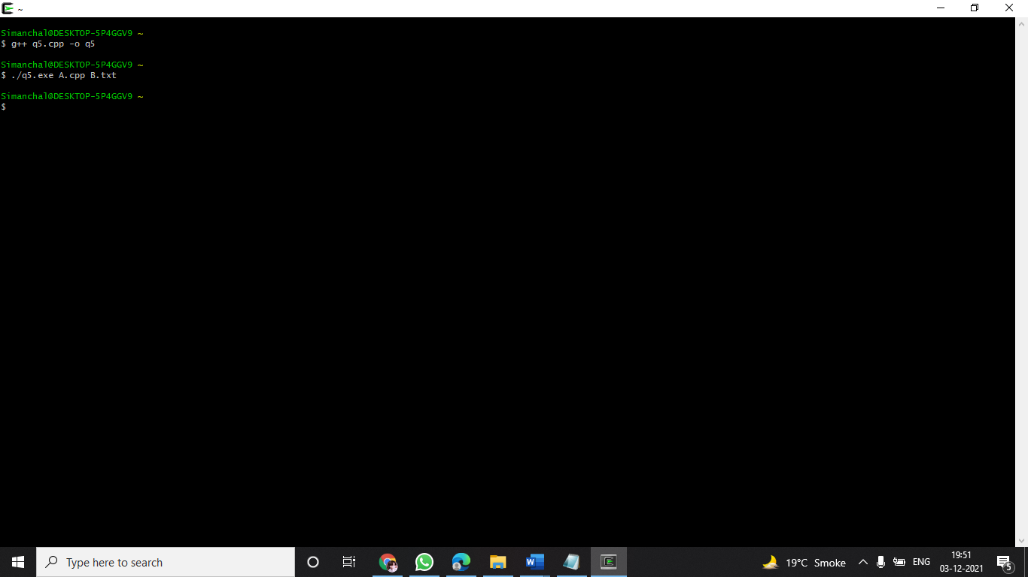

QUESTION 7:-

Write a program to implement FCFS scheduling algorithm.

code:

#include<iostream>

using namespace std;

int main()

{

int n;

cout<<"=====================================================";

cout<< "\n FCFS "<<endl;

cout<<"\n====================================================="<<endl;

cout<<"\nEnter number of process:";

cin>>n;

int burst_time[n];

for(int i=1; i<=n; i++)

{

cout<<"Enter Burst time for P"<<i<<": ";

cin>>burst_time[i];

}

int wait_time[n];

wait_time[1]=0;

for(int i=2; i<=n; i++)

{

wait_time[i]=wait_time[i-1]+burst_time[i-1];

}

int turnaround_time[n];

for(int i=1; i<=n; i++)

{

turnaround_time[i]=wait_time[i]+burst_time[i];

}

float total_wait_time=0, total_turnaround_time=0;

float avg_wait_time, avg_turnaround_time;

for(int i=1;i<=n;i++)

{

total_wait_time+= wait_time[i];

total_turnaround_time+= turnaround_time[i];

}

cout<<" Burst Time Waiting Time Turnaround Time"<<endl;

for(int i=1; i<=n; i++)

{

cout<<"P"<<i<<" "<<burst_time[i]<<" "<<wait_time[i]<<" "<<turnaround_time[i]<<endl;

}

avg_wait_time= total_wait_time/n;

avg_turnaround_time= total_turnaround_time/n;

cout<<"\nAverage wait time ="<<avg_wait_time<<endl;

cout<<"\nAverage turnaround time ="<<avg_turnaround_time<<endl;

return 0;

}

OUTPUT:

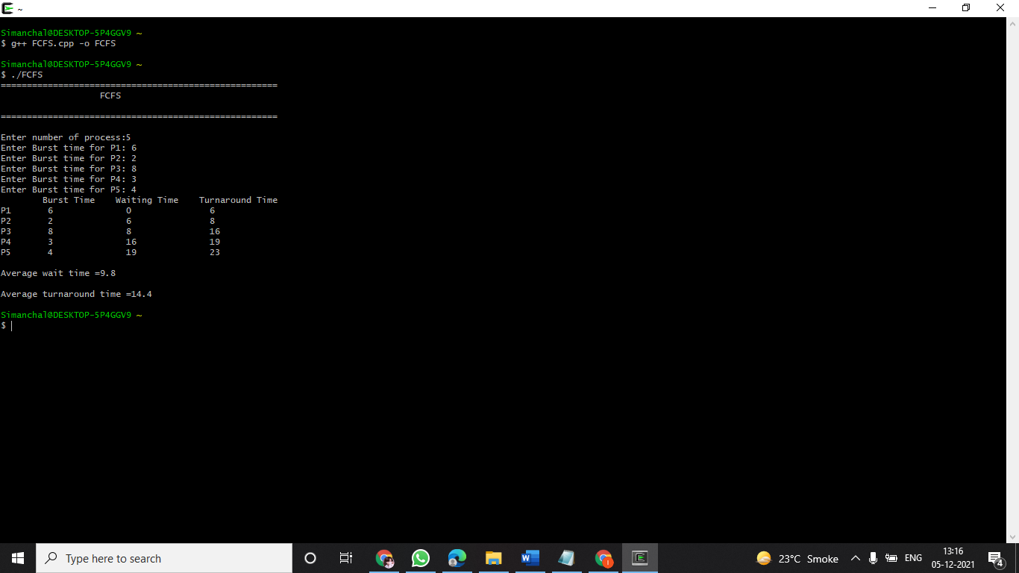

QUESTION 8:-

Write a program to implement Round Robin scheduling algorithm.

CODE:

#include <iostream>

#include <vector>

using namespace std;

int main()

{

cout<<"=====================================================";

cout<< "\n ROUND ROBIN "<<endl;

cout<<"\n====================================================="<<endl;

int count,j,n,time,remain,flag=0,time_quantum,i=0;

int wt=0,tat=0,at[20],bt[20],rt[20],gantt[20][2];

cout<<"\nEnter no of Processes : ";

cin>>n;

cout<<"Enter Time Quantum : ";

cin>>time_quantum;

remain=n;

cout<<"*****ENTER DETAILS*****"<<endl;

for(count=0;count<n;count++)

{

cout<<"\nPId : "<<count+1;

cout<<"\nArrival Time : ";

cin>>at[count];

cout<<"Burst Time : ";

cin>>bt[count];

rt[count]=bt[count];

}

cout<<"\nPId\tAt\tbt\n";

for(count=0; count<n; count++)

{

cout<<count+1<<"\t"<<at[count]<<"\t"<<bt[count]<<"\n";

}

cout<<"\n\nPId\tTAT\tWT\n";

for(time=0,count=0;remain!=0;)

{

if(rt[count]<=time_quantum && rt[count]>0)

{

time+=rt[count];

rt[count]=0;

gantt[i][0]= count;

gantt[i][1]= time;

i++;

flag=1;

}

else if(rt[count]>0)

{

rt[count]-=time_quantum;

time+=time_quantum;

gantt[i][0]= count;

gantt[i][1]= time;

i++;

}

if(rt[count]==0 && flag==1)

{

remain--;

cout<<count+1<<"\t"<<time-at[count]<<"\t"<<time-at[count]-bt[count]<<"\n";

wt+=time-at[count]-bt[count];

tat+=time-at[count];

flag=0;

}

if(count==n-1)

count=0;

else if(at[count+1]<=time)

count++;

else

count=0;

}

cout<<"\nAverage Waiting Time="<<wt*1.0/n<<endl;

cout<<"Avg Turnaround Time ="<<tat*1.0/n<<endl;

cout<<endl<<"*****Gantt Chart*****"<<endl<<"PID\tEnd Time\t"<<endl;

for(int k=0;k<i;k++)

{

cout<<gantt[k][0]+1<<"\t"<<gantt[k][1]<<"\t"<<endl;

}

return 0;

}

OUTPUT:

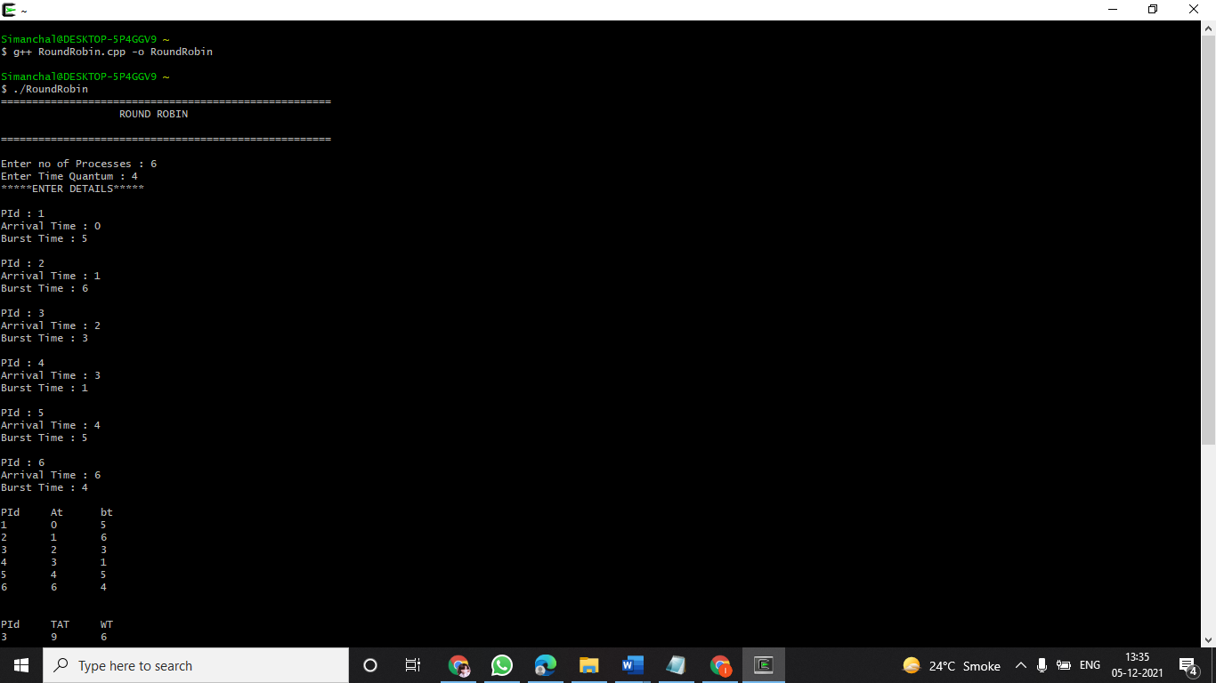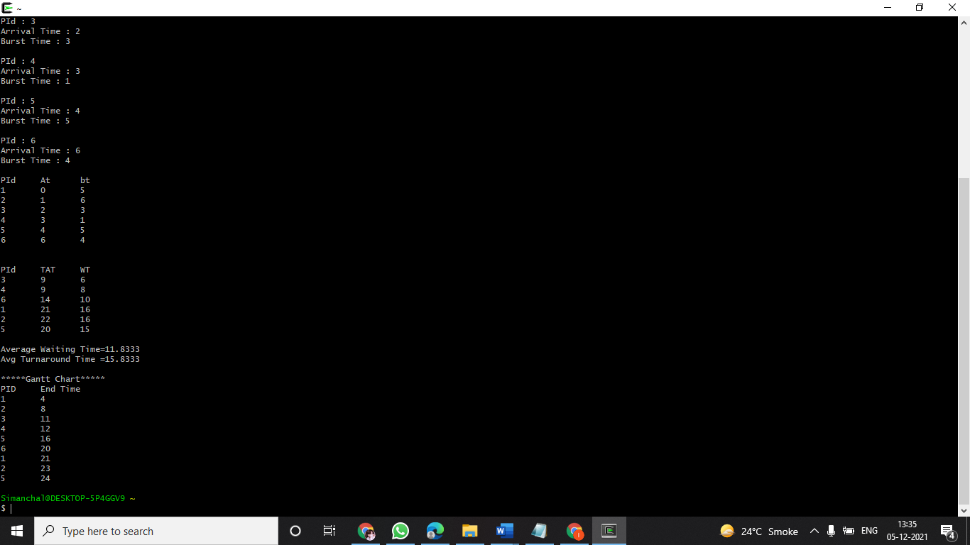

QUESTION 9:-

Write a program to implement SJF scheduling algorithm.

CODE:

#include <iostream>

using namespace std;

int mat[10][6];

void swap(int* a, int* b)

{

int temp = *a;

*a = *b;

*b = temp;

}

void arrangeArrival(int num, int mat[][6])

{

for (int i = 0; i < num; i++)

{

for (int j = 0; j < num - i - 1; j++)

{

if (mat[j][1] > mat[j + 1][1])

{

for (int k = 0; k < 5; k++)

{

swap(mat[j][k], mat[j + 1][k]);

}

}

}

}

}

void completionTime(int num, int mat[][6])

{

int temp, val;

mat[0][3] = mat[0][1] + mat[0][2];

mat[0][5] = mat[0][3] - mat[0][1];

mat[0][4] = mat[0][5] - mat[0][2];

for (int i = 1; i < num; i++)

{

temp = mat[i - 1][3];

int low = mat[i][2];

for (int j = i; j < num; j++)

{

if (temp >= mat[j][1] && low >= mat[j][2])

{

low = mat[j][2];

val = j;

}

}

mat[val][3] = temp + mat[val][2];

mat[val][5] = mat[val][3] - mat[val][1];

mat[val][4] = mat[val][5] - mat[val][2];

for (int k = 0; k < 6; k++) {

swap(mat[val][k], mat[i][k]);

}

}

}

int main()

{

cout<<"======================================================================"<<endl;

cout<<" SJf "<<endl;

cout<<"======================================================================"<<endl;

int num, temp;

cout << "Enter number of Process: ";

cin >> num;

cout << "...Enter the process ID...\n";

for (int i = 0; i < num; i++)

{

cout << "...Process " << i + 1 << "...\n";

cout << "Enter Process Id: ";

cin >> mat[i][0];

cout << "Enter Arrival Time: ";

cin >> mat[i][1];

cout << "Enter Burst Time: ";

cin >> mat[i][2];

}

cout << "Before Arrange...\n";

cout << "Process ID\tArrival Time\tBurst Time\n";

for (int i = 0; i < num; i++)

{

cout << mat[i][0] << "\t\t" << mat[i][1] << "\t\t"

<< mat[i][2] << "\n";

}

arrangeArrival(num, mat);

completionTime(num, mat);

cout << "Final Result.."<<endl;

cout << "Process ID\tArrival Time\tBurst Time\tWaiting "

"Time\tTurnaround Time\n";

for (int i = 0; i < num; i++)

{

cout << mat[i][0] << "\t\t" << mat[i][1] << "\t\t"

<< mat[i][2] << "\t\t" << mat[i][4] << "\t\t"

<< mat[i][5] << "\n";

}

return 0;

}

OUTPUT:

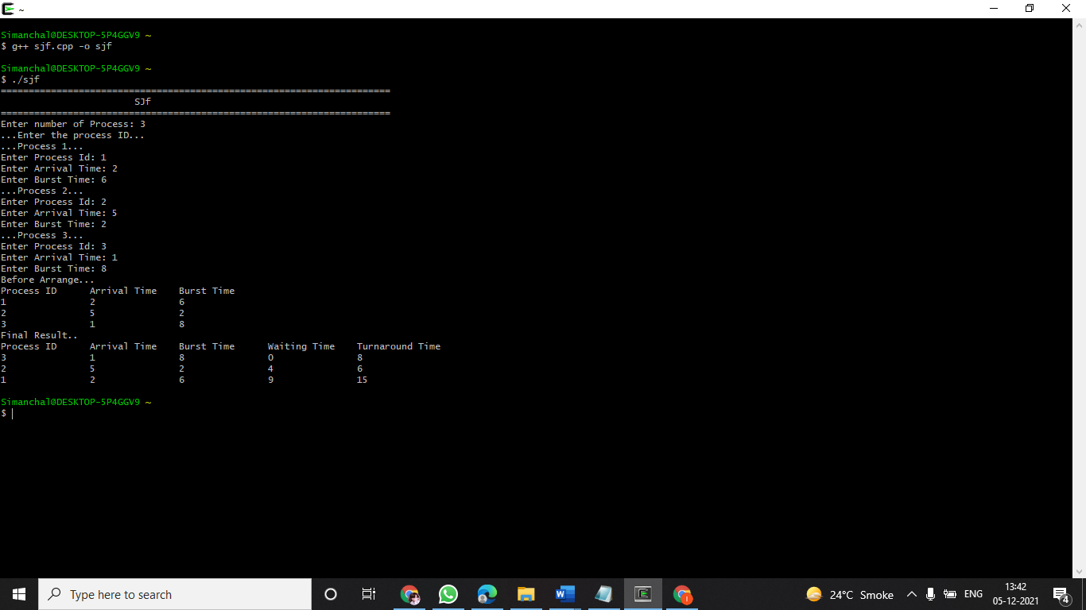

QUESTION 10:-

Write a program to implement non-preemptive priority based scheduling algorithm.

CODE:

#include<iostream>

using namespace std;

int ct=0,i=0,wp[25]={0},comp[25];

void TurnAroundTime(int i,int at[],int tat[],int qt)

{

tat[i] = qt-at[i];

comp[i]=qt;

}

void WaitingTime(int tat[], int n, int bt[], int wt[])

{

for(int i=0;i<n;i++)

{

wt[i]=tat[i]-bt[i];

}

}

void waitingQueue(int dup_bt[],int n,int processes[],int at[],int tat[])

{

for(int i=0;i<n;i++)

{

int j=0; j=ct;

if(dup_bt[i]!=0)

{

ct=ct+dup_bt[i];

dup_bt[i]=0;

TurnAroundTime(i,at,tat,ct);

}

}

}

void ReadyQueue(int processes[],int bt[],int at[],int n,int pri[])

{

int dup_bt[n],tat[n],wt[n];

for(int i=0;i<n-1;i++)

{

for(int j=0;j<n-1;j++)

{

if(pri[j]<pri[j+1])

{

int t=0;

t=at[j];

at[j]=at[j+1];

at[j+1]=t;

t=processes[j];

processes[j]=processes[j+1];

processes[j+1]=t;

t=bt[j];

bt[j]=bt[j+1];

bt[j+1]=t;

t=pri[j];

pri[j]=pri[j+1];

pri[j+1]=t;

}

else if(pri[j]==pri[j+1]&&at[j]>at[j+1])

{

int t=0;

t=at[j];

at[j]=at[j+1];

at[j+1]=t;

t=processes[j];

processes[j]=processes[j+1];

processes[j+1]=t;

t=bt[j];

bt[j]=bt[j+1];

bt[j+1]=t;

t=pri[j];

pri[j]=pri[j+1];

pri[j+1]=t;

}

}

}

cout<<"\nProcesses "<<" Arrival Time "<<" Burst Time "<<" Priority \n";

for (int i=0;i<n;i++)

{

cout<<" "<<processes[i]<<"\t\t"<<at[i]<<"\t "<<bt[i]<<"\t "<<pri[i]<<"\t "<<endl;

}

for(int i=0;i<n;i++)

dup_bt[i] = bt[i];

for(int i=0;i<n;i++)

{

for(int j=0;j<n;j++)

{

if(dup_bt[j]!=0)

{

if(ct==at[j]||ct>at[j])

{

i=ct;

int l=0;

ct=ct+dup_bt[j];

dup_bt[j]=0;

TurnAroundTime(j,at,tat,ct);

j=n;

}

}

}

}

waitingQueue(dup_bt,n,processes,at,tat);

WaitingTime(tat,n,bt,wt);

cout<<"\nProcesses "<<" Arrival Time "<<" Burst Time "<<" Turn Around Time "<<" Compilation Time "<<" Waiting Time "<<"\n";

for(int i = 0 ; i < n ; i++)

cout<<" "<<processes[i]<<"\t\t "<<at[i]<<"\t "<<bt[i]<<"\t "<<tat[i]<<"\t "<<comp[i]<<"\t "<<wt[i]<<"\n";

}

int main()

{

cout<<"================================================================================";

cout<< "\n NON PREEMPTIVE PRIORITY SCHEDULING "<<endl;

cout<<"================================================================================"<<endl;

int n;

cout<<"Enter no. of Processes: ";

cin>>n;

cout<<endl;

int processes[n];

int bt_time[n];

int a_time[n];

int priority[n];

for(int i=0;i<n;i++)

{

processes[i]=i+1;

cout<<"Enter Burst Time of P["<<i+1<<"]: ";

cin>>bt_time[i];

cout<<"Enter Arrival Time of P["<<i+1<<"]: ";

cin>>a_time[i];

cout<<"Enter Priority of P["<<i+1<<"]: ";

cin>>priority[i];

cout<<endl;

}

cout<<endl;

cout<<"Processes "<<" Arrival Time "<<" Burst Time "<<" Priority \n";

for(int i=0;i<n;i++)

{

cout<<" "<<processes[i]<<"\t\t"<<a_time[i]<<"\t "<<bt_time[i]<<"\t "<<priority[i]<<"\t "<<endl;

}

ReadyQueue(processes,bt_time,a_time,n,priority);

return(0);

}

OUTPUT:

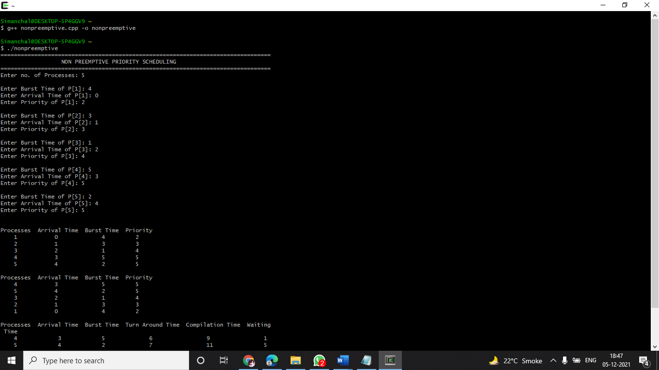

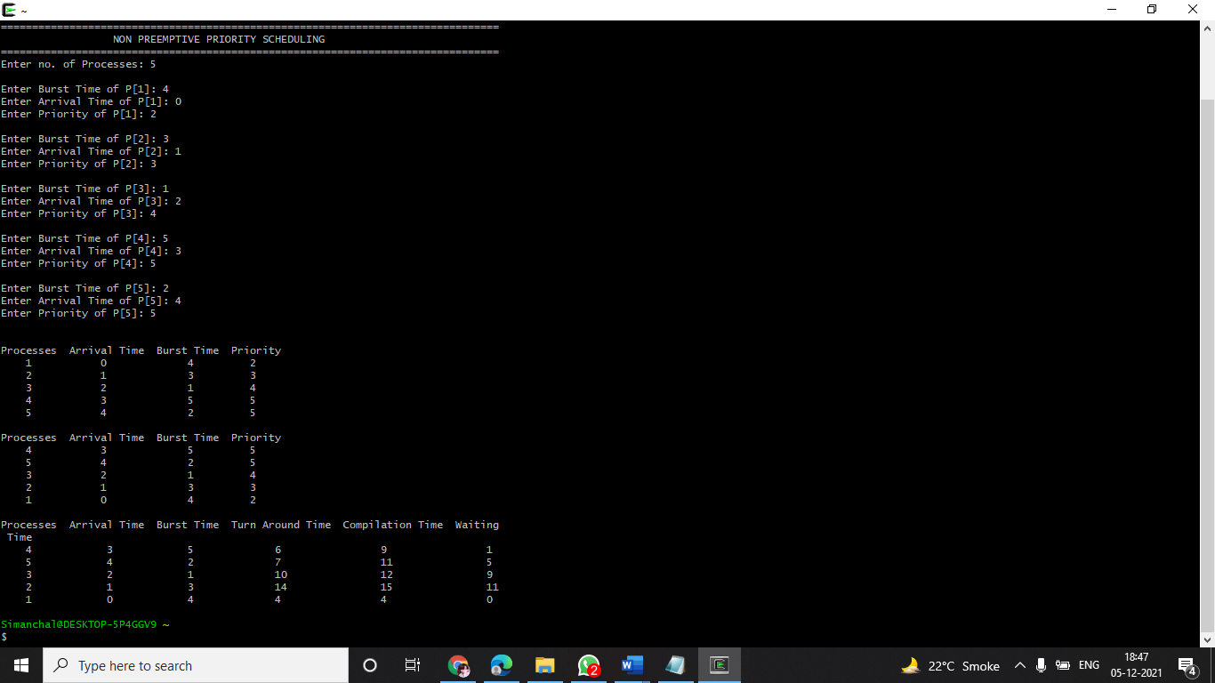

QUESTION 11:-

Write a program to implement preemptive priority based scheduling algorithm.

CODE:

#include<iostream>

using namespace std;

class Process

{

int pid;

int at;

int bt;

int rt;

int priority;

int n;

int completed_flag;

Process *proc;

public:

void input();

void sort_at();

void prem_priority();

};

void Process :: input()

{

cout<<"\nEnter no of Processes : ";

cin>>n;

cout<<endl;

proc=new Process[n];

cout<<"ENTER DETAILS"<<endl;

cout<<endl;

for(int i=0;i<n;i++)

{

cout<<"Enter the PId for Process "<<i+1<<" : ";

cin>>proc[i].pid;

cout<<"Enter the Process Arrival Time for Process " <<i+1<<" : ";

cin>>proc[i].at;

cout<<"Enter the Process Burst Time for Process "<<i+1<<" : ";

cin>>proc[i].bt;

cout<<"Enter the Priority for Process "<<i+1<<" : ";

cin>>proc[i].priority;

cout<<endl;

proc[i].completed_flag=0;

proc[i].rt=proc[i].bt;

cout<<endl;

}

cout<<"\nPId\tAt\tBt\tPriority\n";

for(int i=0; i<n; i++)

{

cout<<proc[i].pid<<"\t"<<proc[i].at<<"\t"<<proc[i].bt<<"\t"<<proc[i].priority<<"\n";

}

}

void Process :: sort_at()

{

for (int i=0; i<n; i++)

{

for(int j=0; j<n-i-1; j++)

{

if(proc[j].at>proc[j+1].at)

{

Process temp=proc[j];

proc[j]=proc[j+1];

proc[j+1]=temp;

}

}

}

}

void Process :: prem_priority()

{

int ct;

sort_at();

cout<<"Execution sequence as follow:\nSelected process info :\n";

cout<<"\nPid\tAT\tBT\tPriority\tST\tCT\n";

for(int count=0,ct=proc[0].at; count<n;ct++ )

{

int selected_process=-1;

for(int i=0; i<n; i++)

{

if(proc[i].at<=ct && proc[i].completed_flag!=1)

{

if(selected_process==-1)

selected_process=i;

else if(proc[selected_process].priority>proc[i].priority)

selected_process=i;

}

else if (proc[i].at>ct)

break;

}

if(selected_process==-1)

{

continue;

}

cout<<proc[selected_process].pid<<"\t"<<proc[selected_process].at<<"\t"<<proc[selected_process].bt<<"\t"<<proc[selected_process].priority<<"\t\t"<<ct<<"\t"<<ct+1<<"\n";

proc[selected_process].rt--;

if(proc[selected_process].rt==0)

{

proc[selected_process].completed_flag=1;

count++;

}

}

}

int main()

{

int n;

cout << "================================================================================";

cout << "\n PREEMPTIVE PRIORITY SCHEDULING " << endl;

cout << "================================================================================" << endl;

Process p;

p.input();

p.prem_priority();

return 0;

}

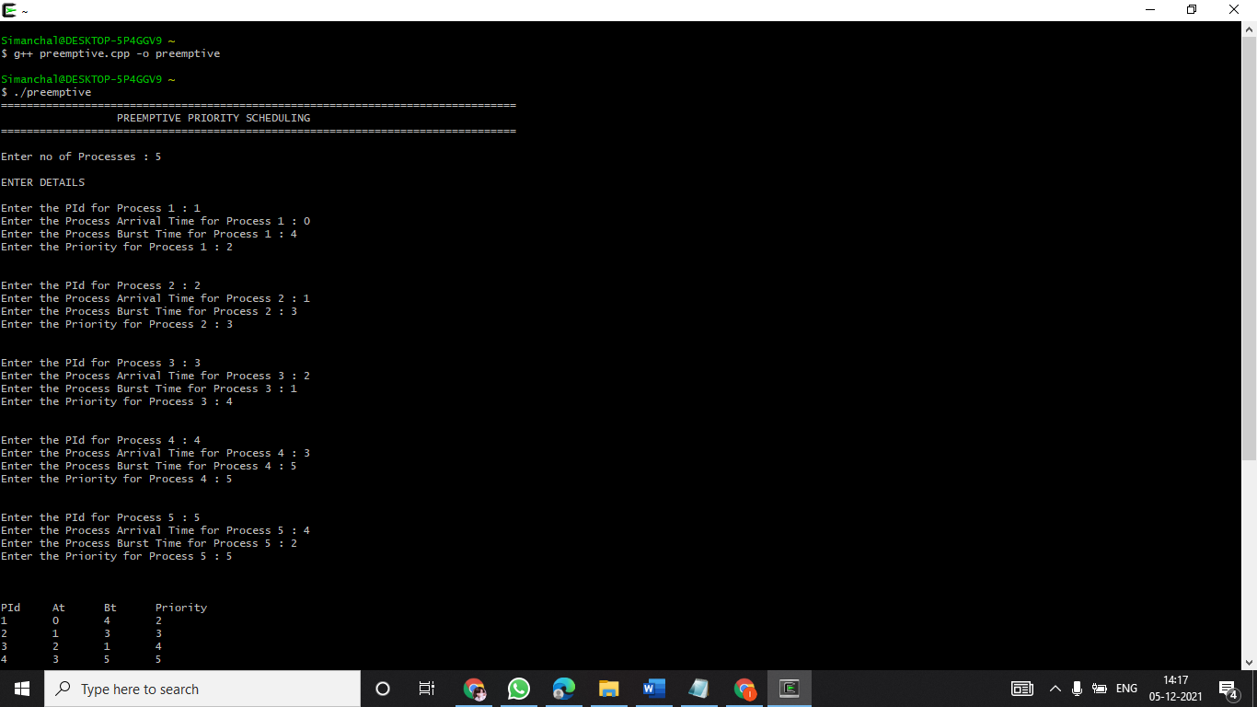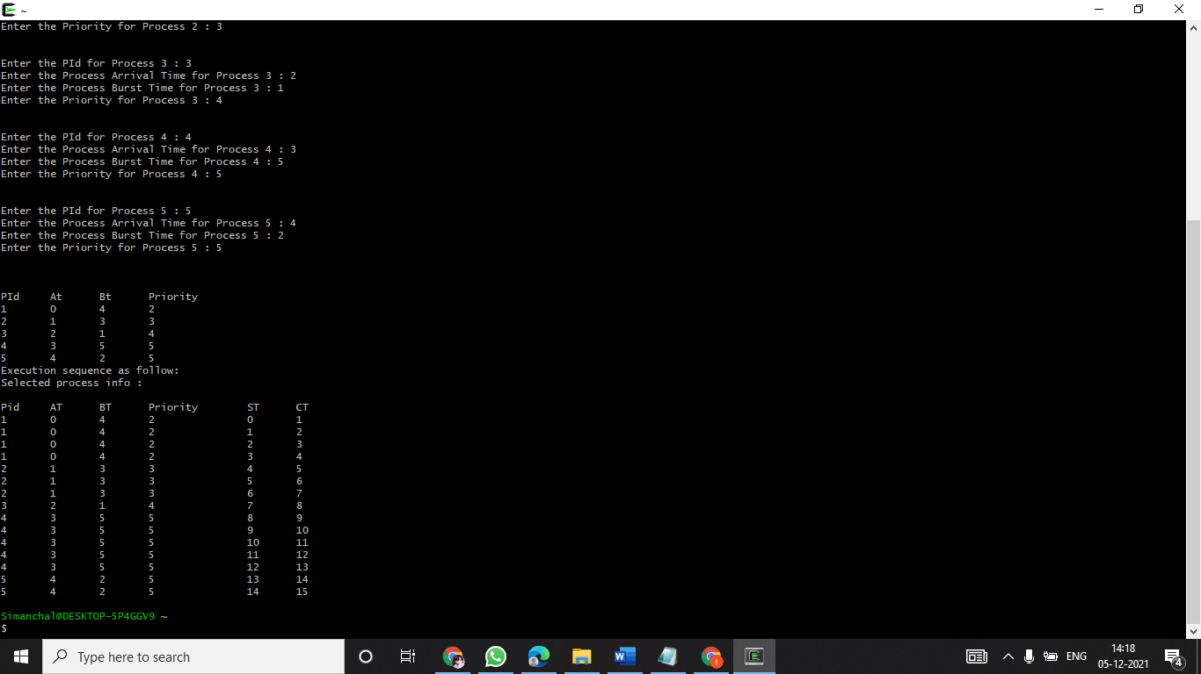

QUESTION 1 2:-

Write a program to implement SRTF scheduling algorithm.

CODE:

#include<iostream>

#include<stdlib.h>

#include<stdio.h>

using namespace std;

int n;

class Process

{

int n,pid,at,bt,tat,st,wt,ct,rt;

int completed_flag;

Process *proc;

public:

void input();

void sort_at();

void srtf();

};

void Process :: input()

{

cout<<"Enter no of Processes :"<<" " <<endl;

cin>>n;

cout<<"\n";

proc=new Process[n];

cout<<"ENTER DETAILS :" <<endl;

for(int i=0; i<n; i++)

{

cout<<"Enter the PId for Process "<<i+1<<" : ";

cin>>proc[i].pid;

cout<<"Enter the Process Arrival Time for Process "<<i+1<<" : ";

cin>>proc[i].at;

cout<<"Enter the Process Burst Time for Process "<<i+1<<" : ";

cin>>proc[i].bt;

cout<<endl;

proc[i].completed_flag=0;

proc[i].rt=proc[i].bt;

}

cout<<"\npid\tAT\tBT\n";

for(int i=0; i<n; i++)

{

cout<<proc[i].pid<<"\t"<<proc[i].at<<"\t"<<proc[i].bt<<"\n";

}

}

void Process :: sort_at()

{

for (int i=0; i<n; i++)

{

for(int j=0; j<n-i-1; j++)

{

if(proc[j].at>proc[j+1].at)

{

Process temp=proc[j];

proc[j]=proc[j+1];

proc[j+1]=temp;

}

}

}

}

void Process :: srtf()

{

int ct;

sort_at();

cout<<"Execution sequence as follow:\nSelected process info :\n";

cout<<"\nPid\tST\tFT\n";

for(int count=0, ct= proc[0].at; count<n;ct++ )

{

int selected_process=-1;

for(int i=0; i<n; i++)

{

if(proc[i].at<=ct && proc[i].completed_flag!=1)

{

if(selected_process==-1)

selected_process=i;

else if(proc[selected_process].rt>proc[i].rt)

selected_process=i;

}

else if (proc[i].at>ct)

break;

}

if(selected_process==-1)

{

ct++;

continue;

}

cout<<proc[selected_process].pid<<"\t"<<ct<<"\t"<<ct+1<<"\n";

proc[selected_process].rt--;

if(proc[selected_process].rt==0)

{

proc[selected_process].completed_flag=1;

count++;

}

}

}

int main()

{

cout<<"======================================================================"<<endl;

cout<<" SRTF "<<endl;

cout<<"======================================================================"<<endl;

Process p;

p.input();

p.srtf();

return 0;

}

OUTPUT:

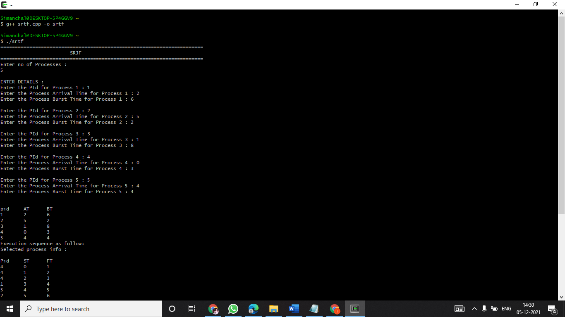

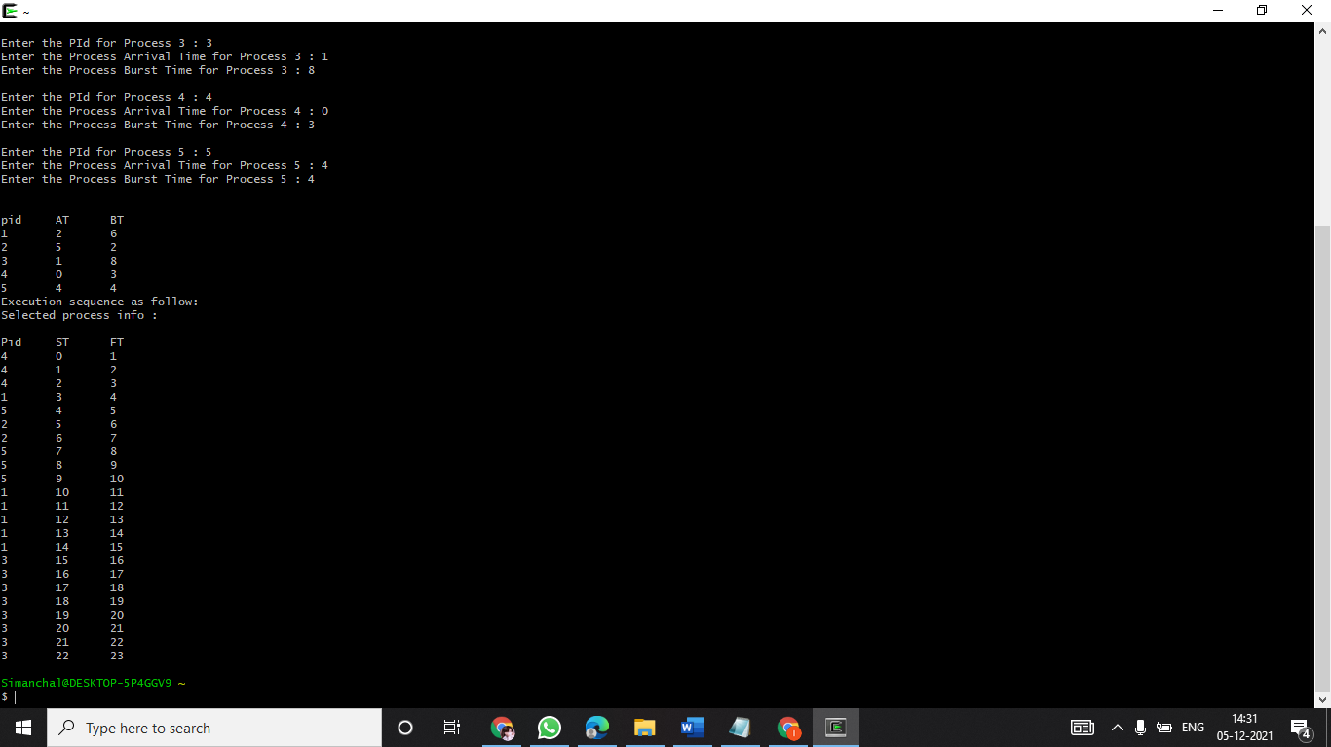

QUESTION 13:-

Write a program to calculate sum of n numbers using thread library.

CODE:

#include<pthread.h>

#include<iostream>

using namespace std;

int sum;

void* runner(void* param);

int main(int argc,char *argv[])

{

pthread_t tid;

pthread_attr_t attr;

if(argc!=2)

{

cout<<"\nUsage :a.out<integer value>\n";

return -1;

}

if(atoi(argv[1])<0)

{

cout<<"\n%d must be >=0\n"<<atoi((const char*)(argv[1]))<<endl;

return -1;

}

pthread_attr_init(&attr); //get the default attributes

pthread_create(&tid,&attr,runner,argv[1]); //create the thread:

pthread_join(tid,NULL); //parent waits for the child thread to finish

cout<<"\nSUM is: "<<sum<<endl;//output the value of shared data "sum"

return 0;

}//child thread will begin execution here:

void* runner(void* param)

{

int i,upper=atoi((const char*)param);

sum=0;

for(i=1;i<=upper;i++)

sum+=i;

pthread_exit(0);

}

OUTPUT:

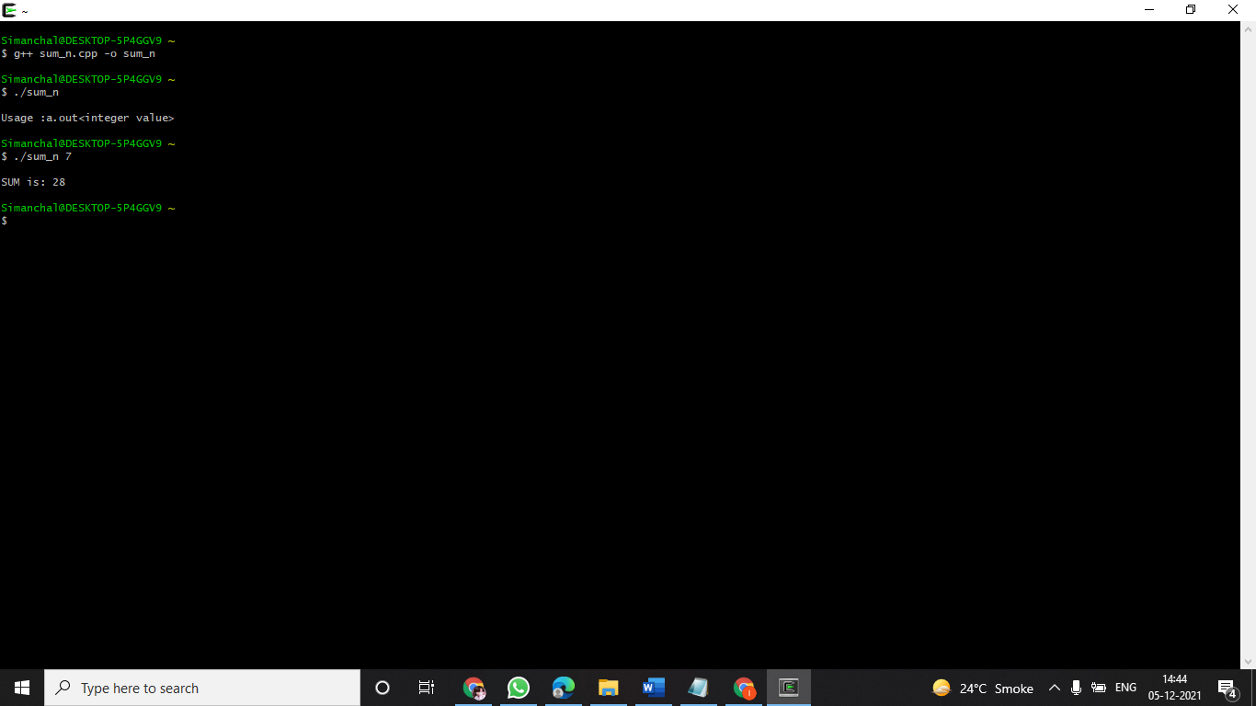

QUESTION 14:-

Write a program to implement first-fit, best-fit and worst-fit allocation strategies.

CODE:

#include <iostream>

using namespace std;

class Fit

{

int p,h;

int *process,*hole;

public:

Fit(int,int);

void input();

void firstFit();

void bestFit();

void worstFit();

};

Fit :: Fit(int n1,int n2)

{

p=n1;

h=n2;

process=new int[p];

hole=new int[h];

}

void Fit :: input()

{

cout<<"Enter the process size :\n";

for(int i=0;i<p;i++)

{

cout<<"Process[" << i+1 << "] : ";

cin>>process[i];

}

cout<<"\nEnter the hole size :\n";

for(int i=0;i<h;i++)

{

cout<<"Hole[" << i+1 << "] : ";

cin>>hole[i];

}

}

void Fit :: firstFit()

{

int flag=1;

for(int i=0;i<p;i++)

{

for(int j=0;j<h;j++)

{

if(process[i]<=hole[j])

{

cout<<"Process size : "<<process[i]<<" -----> Hole Size : "<< hole[j] <<endl;

int flag=0;

hole[j]-=process[i];

break;

}

}

}

}

void Fit :: bestFit()

{

int loc,temp,min;

for(int i=0;i<h-1;i++)

{

min=hole[i];

loc=i;

for(int j=i+1;j<h;j++)

{

if(min>hole[j])

{

min=hole[j];

loc=j;

}

}

temp=hole[i];

hole[i]=hole[loc];

hole[loc]=temp;

}

for(int i=0;i<p;i++)

{

for(int j=0;j<h;j++)

{

if(process[i]<=hole[j])

{

cout<<"Process size : "<<process[i]<<" -----> Hole Size : "<<hole[j]<<endl;

hole[j]-=process[i];

break;

}

}

}

}

void Fit :: worstFit()

{

int flag=1;

if(p<=h)

{

for(int i=0;i<p;i++)

{

for(int j=i+1;j<h;j++)

{

if(hole[i]<hole[j])

{

int temp=hole[i];

hole[i]=hole[j];

hole[j]=temp;

}

}

}

for(int i=0;i<p;i++)

{

for(int j=0;j<h;j++)

{

if(process[i]<=hole[j])

{

cout<<"Process size : "<<process[i]<<" -----> Hole Size : "<<hole[j]<<endl;

flag=0;

hole[j]=0;

break;

}

else

flag=1;

}

if(flag==1)

cout<<"Process size : "<<process[i]<<" -----> Not Allocated"<<endl;

}

}

}

int main()

{

char ans='y';

int p,h,choice;

do

{

cout<<"Enter number of processes : ";

cin>>p;

cout<<"Enter number of holes : ";

cin>>h;

Fit f(p,h);

f.input();

cout<<"\n*****CHOOSE ALLOCATION STRATEGY*****\n";

cout<<"1.First Fit\n";

cout<<"2.Best Fit\n";

cout<<"3.Worst Fit\n";

cout<<"\nYour Choice : ";

cin>>choice;

switch(choice)

{

case 1:

f.firstFit();

break;

case 2:

f.bestFit();

break;

case 3:

f.worstFit();

break;

default:

cout<<"Make a valid choice\n";

break;

}

cout<<"\nWant to continue?(Y/n): ";

cin>>ans;

}while(ans=='Y' || ans=='y');

return 0;

}

OUTPUT:

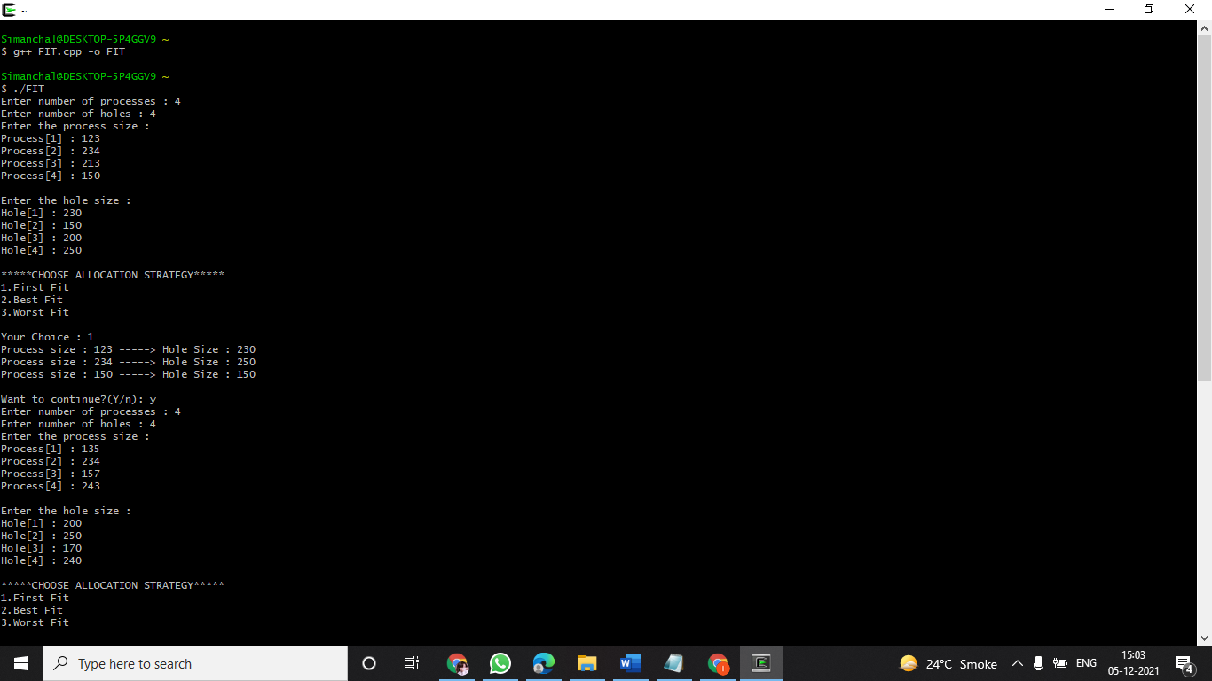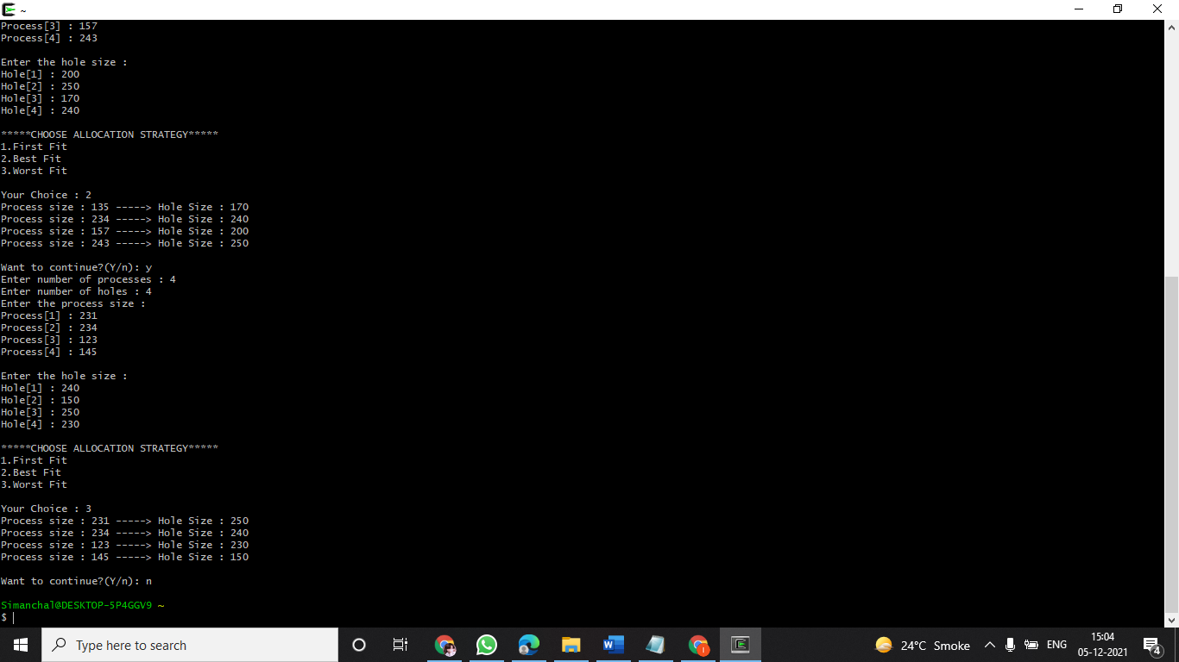

15-CODE:

#include<iostream>

#include<unistd.h>

#include<sys/types.h>

#include<sys/wait.h>

using namespace std;

int main()

{

int ID1=fork();

int ID2=fork();

if(ID1<0)

cout<<"\n Unsuccessful \n";

if(ID1==0)

cout <<" Im child pid = " << getpid() <<" return ID1: "<< ID1<<"\n";

else

cout <<" Im parent pid = " << getpid() <<" return ID1: "<< ID1<<"\n";

if(ID2<0)

cout<<"\n Unsuccessful \n";

if(ID2==0)

cout <<" Im child pid = " << getpid() <<" return ID2: "<< ID2<<"\n";

else

cout <<" Im parent pid = " << getpid() <<" return ID2: "<< ID2<<"\n";

return 0;

}

OUTPUT:

